# validation

The validation intends to check the performance of Brazilian version of COPA model. In order to attend this objective, we have done an exercise of comparison our results with Brazilian National System Operator (ONS) observed electricity dispatch. We analyzed it for one year, 2012, in a daily basis. Besides the fact COPA results are in hourly basis, ONS makes available data in daily basis. That is the reason we compare the results in a daily basis.

We used data from Newave deck of December 2012. This is the software used to simulate the electrical system operation. The ONS publishes this deck containing all information used as input to Newave on each month. We used data related to hydro power of subsystems, transmission lines capacities and variable costs of thermal plants in operation by December 2012. Besides this data, we used some more information achieved on ONS website, like hydro inflows, reservoir parameters (initial and final levels and maximum capacity) and hourly load.

We have also got installed wind capacity data from electricity market regulator website (ANEEL). In terms of hourly time series of wind and solar capacity factors, we collected data at Renewables Ninja website.

In order to make sure we were working with a consistent model, we verified if COPA was respecting the bounds and if renewables profiles resources used as input were making sense. For example, we had more inflows during the humid period than the dry one in all subsystems. We observed greater wind resource during the dry period than the humid one as well. We also double checked the transmission lines limits and thermal plants variable costs.

The validation begins with the fixation of initial and terminal levels of each subsystem reservoirs. We got this information on ONS website and added to model as a parameter. It was necessary in order to avoid the model to empty all reservoirs by the end of the period. It could happen, because the hydro generation has zero variable cost and large availability. Once this specialization in hydro is not compatible with the real operation pattern, we had to limit reservoir levels.

Once we had the results, comparing total inflows and total hydro electricity generation of ONS and COPA, the second one was overestimating in 7% the first one generation. In order to correct that, we`ve multiplied COPA inflows by 93%, which we call inflows calibration factor. Figure 1 and Figure 2 show total hydro generation of ONS and COPA on daily basis and on monthly basis. The figure XX shows the thermal generation from ONS and COPA.



Figure 1: Hydro total generation. Daily basis

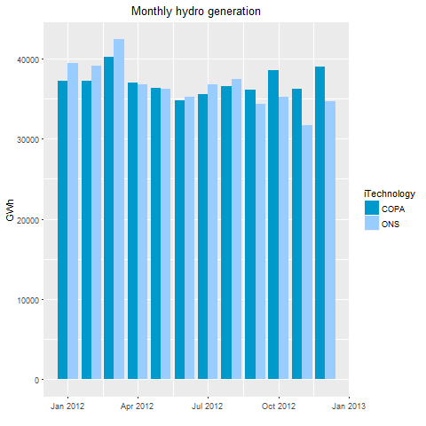

Figure 2: Monthly hydro generation

There are some differences in hydro generation mainly in the end of the year probably because COPA does not deal with the hydrological uncertainties. Besides that, there are two points we do not consider: reservoir evaporation and hourly variability of reservoir storage levels. These factors can be responsible for this 7% difference between total hydro generation from ONS and COPA on 2012.

Besides the fact that inflows are not certain, the second half of the year is the driest period in Brazil usually, and so it may justifies greater thermal dispatch by ONS. Other factor to be considered is that the load is uncertainty as well. It has a well-defined shape depending on year season, but the pick is always suitable to changes. Sometimes it is necessary to dispatch more thermal plants to deal with rapid load changes.



Figure 3: Thermal total generation. Daily basis

A third uncertainty during the operation of Brazilian electrical system is regard the installation of new plants. Sometimes the ONS is counting on some power plant is going to operate and it does not occur. Because of that thermal generation can be an option in order to maintain the load attendance. Therefore it is very important to notice which plants are generating in each moment to verify when these plants contribute to the system.

By the results, we can infer that COPA uses thermal plants like a base generation. It is common that the main variations in generation occur with renewables, hydro, wind and solar, because of the availability of resources and thermal plants come to compensate these fluctuations. Even though ONS thermal generation does not seems that stable, it seems ONS uses certain thermal plants as base generation as well, because they are relatively cheap and due operational constraints. For example, Brazil has two nuclear power plants in operation. They have relatively low variable costs and slowly in decommissioning. Therefore once in operation, they tend to remain operating.

The figure XX shows the examination of wind generation. We observe a shape compatible with the wind profile in Brazil. This means less production during the wet period and more generation during the dry period. Both, COPA and ONS follow the resources availability. COPA is more optimistic between July and October though. Probably it is because some shutdown maintenance or delay in some plant start-up. The wind generation took place in two subsystems: Northeast and South.

In terms of comparison by regions, table XX shows the correlation and root-mean-square deviation (RMSE) from ONS and COPA generation. The greatest correlation is observed in hydro generation in North region (81%) and the smallest RMSE is on thermal in South region.

Figure 4: Wind total generation. Daily basis

Table 1: Statistical indicators per region

|  |  |  |  |
| --- | --- | --- | --- |
| Region | Technology | Correlation | RMSE |
| SE | Hydro | 0.64 | 78.97 |
| SE | Thermal | -0.09 | 2.22 |
| S | Hydro | 0.28 | 55.69 |
| S | Thermal | 0.01 | 0.25 |
| S | Wind | 0.42 | 1.26 |
| NE | Hydro | -0.01 | 56.87 |
| NE | Thermal | 0.00 | 0.13 |
| NE | Wind | 0.47 | 2.33 |
| N | Hydro | 0.81 | 29.73 |
| N | Thermal | NA | 0.00 |

Source: Own Elaboration

However, the best approach is considering both indicators together instead of isolated. Doing so COPA best’s performance is on hydro and wind generation. These numbers shows that COPA and ONS results have similar paths with a reasonable root-mean-square deviation when it comes to hydro on SE and N and wind on S and NE.

Concluding, taking into account that COPA is a deterministic model, we do not deal with hydrological, load and planning uncertainties. It has perfect foresight, knowing all the inflows and load variations in the beginning of the period. Because of that, some differences would be expected.